# **Introduction:**

A **non-governmental organization** (**NGO**) is a not-for-profit organization that is independent from states and international governmental organizations. They are usually funded by donations but some avoid formal funding altogether and are run primarily by volunteers. NGOs are highly diverse groups of organizations engaged in a wide range of activities, and take different forms in different parts of the world.

To communicate with the people NGO Management system is vastly used now a days. This project promotes the interaction between a NGO named ‘Seba’ with their customers.

## **Motivation for this Project:**

With the incensement of various NGO companies in our country, the number of people interacting with them is very high. As Bangladesh is becoming more digitalized day by day the NGO companies needed to evolve themselves to be in the right track. So they are motivated to automate their current systems which is a great opportunity for the Software Development industry. So we decided to select this project so that we can solve a real life problem with vast resources.

## **Project Goals:**

* Web Based UI: User Interface of this project will contain a website to interact with the users. This will help users to easily understand the events and the features of the project.
* Micro-Credit Management: Micro-Credit management will help the organization to track the lone and amount of the loan. It will also perform the task of due date of loan submission and calculate the interest rate.
* Social Activity Management: In this section social activities like Education, Blood donation programmes will be featuring event dates and location. This task will be processed periodically.
* Social Awareness Management: This part will deal with social awareness activities like Health Issues, Women Empowerment. Event date, location & participated persons will be recorded via database
* Registration Process: Organization will be dealing with a large number of people for various events. Registration process will track those users according to the events they are currently performing.
* Activities Time Schedule: Current & Upcoming events of the organization will be described in this section. So users can check their regular performance. Users can also look up for their upcoming activities which they are interested about.
* Previous Successful Activities: This section will keep track of the previous activities that has been completed successfully by the organization

## **Project Feasibilities:**

* Programming Language: PHP, HTML, JavaScript
* Style: CSS
* IDE: Bracket, Notepad++
* Database: MySQL
* Operating System: Windows/Linux

1. Technical Feasibility

* As developers we will be using personal laptops and computers which will decrease the project cost drastically.
* All the softwares, we will be using is free or open sourced. So the project will demand no cost for these softwares.
* As Windows is the most common operating system in the current era, this will conduct a good value to the customers and the client.

The above arguments show clear aspect of feasibility in technical section

1. Economic Feasibility

* Cost of the H/W & S/W is greatly reduced because of personal laptops and free Softwares that we need to perform our dedicated job.
* Resources collected from the companies will be nearly zero as we have connection with several NGO.
* If a system analyst is required the salary will be given according to the profit of the project.
* Professionals will be hired to update the content of the website as an admin. As a result the process will run at a smooth motion.

1. Operational Feasibility

* As most of the users of this project are armatures, we will be constructing the website as their requirements
* User Interface will be simple for the novice users but we will not compromise with the efficiency as well
* Maintenance will be very short run and optimized
* As users are quite armatures, we will be covering the error handling process to make sure users do not perform anything unusual

## **Cost Benefit Analysis:**

* Client Sided Cost
* Hardware cost to perform the task will be fixed once the project proposal is finalized.
* Internet bill will be fixed but electricity bill will vary from month to month as per usage.
* Repair cost may be added if any hardware or equipment is not functional or damaged
* Other various costs may appear during the project
* Client Sided Benefit
* Web based interface to communicate with the users easily and efficiently.
* Incensement of brand value.
* Customer satisfaction can be achieved very professionally.
* Customer will be engaged to perform at a very large scale which will increase the customer rate.
* Developer Sided Cost
* Programmer’s will be giving enough time to create the system successfully
* Collecting data and information cost may vary depending on the process.
* Internet bill and electricity bill will be provided.
* System Settings may cost some money according to system architecture.
* Developer Sided Benefit
* As developers this project will be a new experience for us.
* Solving a real life problem will boost us in the upcoming projects.
* Payment from the client is the main benefit of this project.
* Present Value:

$$PV=\frac{FV}{{(1+i)}^{n}}$$

$$PV=Present Value, FV=Future Value, i=Interest rate in \%, n=time (year)$$

$$if FV=100, i=50\% \& n=.5(6 months)$$

$$PV=\frac{100}{{(1+.5)}^{.5}}$$

$$PV=81.65$$

* Future Value:

$$FV=PV*{(1+i)}^{n}$$

$$if PV=81.65, i=50\% \& n=.5(6 months)$$

$$FV=81.65*{(1+.5)}^{.5}$$

$$FV=100$$

## **Project Scheduling**

|  |  |  |  |
| --- | --- | --- | --- |
| **Activity** | **Description** | **Precedence** | **Time (in week/s)** |
| Analysis | | | |
| 1 | Job Specification | None | 1 |
| 2 | Research on Market | 1 | 1 |
| 3 | Requirement Gathering | 2 | 1 |
| 4 | Project Initiation | 1,2 | 1 |
| Planning | | | |
| 5 | System Design | 4 | 1 |
| 6 | Database Design | 5 | 1 |
| 7 | Mock-up Database Implementation | 6 | 1 |
| Construction | | | |
| 8 | User Interface Designing | 5 | 2 |
| 9 | Admin Panel Designing | 5 | 1 |
| 10 | Coding | 5,6 | 4 |
| Deployment | | | |
| 11 | Testing | 8,9,10 | 2 |
| 12 | Feedback & Releasing | 11 | 1 |

## **Project Scheduling (Gantt chart):**

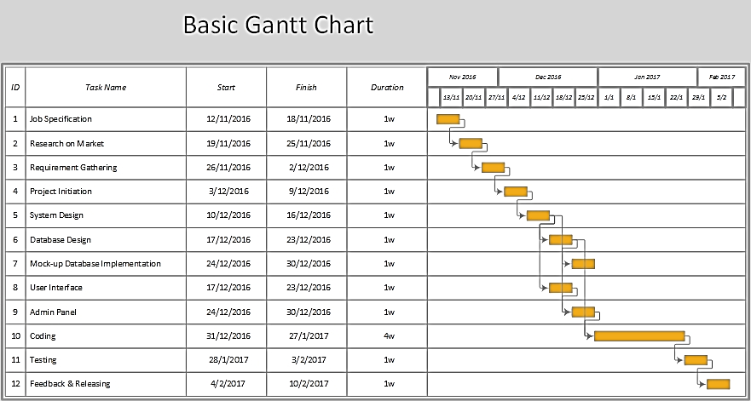

**Risk Analysis:**

* Extra database must be initialized for back up.
* Whole project process will be kept in cloud (Dropbox).
* Security of the database & registration process will be top priority.
* Timing is very valuable for this project. 12 weeks will be tightly scheduled to perform the task successfully before the deadline.
* Some extra hardware’s would be necessary in case of emergency.

## **Conclusion:**

Details of this project is documented in this to overview the features, feasibilities, cost-benefit analysis, present value, project scheduling & risk analysis. This document also represents our interest for selecting this project and market value of this project. We hope to work forward efficiently in this project.

## 